****

**Problem Statement: (Brief)**

The ongoing spread of COVID-19 (coronavirus) has placed a near mandate in keeping an organization’s people safe leading to recognize the positive role of remote/virtual working. These recent events have truly rewritten what is required to ensure effective business continuity. Companies recognize the challenge of locating large workforces (remote/office), need to be prepared for space occupancy. Employees on other hand need details on space availability, peers working location (remote/office), safe route to reach.

**Solution using Technology**

Technology can be used to help

1. Organizations get details on current / planned working location of their employees.
2. Reduce any huddles of space/cubicle availability
3. Provide a safe route
4. Employees can locate where their peers are working from
5. Employees can plan ahead on their work location

**Idea - GameChanger:**

The Idea is to help to prepare for the Unexpected when organisations plan to shift working culture to remote.

With IBMCloud, Watson Services & supporting technologies employer & employee will be enabled to plan & take decisions on their work day seamlessly.

**Demo Video**

<https://github.com/sharmilamathan/WiTHackathon-KnowWhere/blob/master/demo_video.mp4>

**The Architecture**

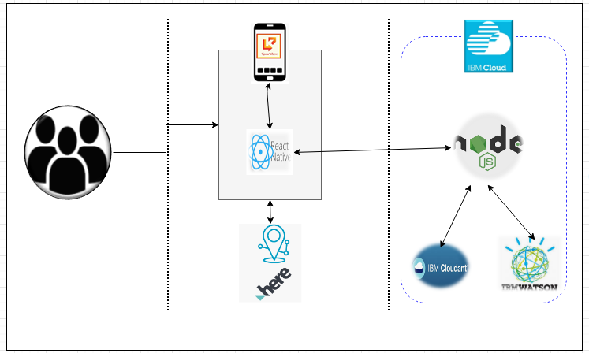

**USERS**

**Problem Statement: (Detail)**

*“About 74 percent of CFOs surveyed by Gartner expect some of their employees who were forced to work from home because of the COVID-19 coronavirus pandemic to continue working remotely after the pandemic ends.”*

Real estate and maintaining facilities are expensive. Many organizations have started exploring & planning for remote working down the lane as getting employees to work from home can help cut facilities costs. On a different angle, Remote Working is also looked as a positive impact to Environment.

When organizations plan for more than 30% of their workforce for remote work, it’s imperative that the business is not impacted. Hence it’s important to be prepared for the culture shift and provide necessary logistics to ensure that the business continues seamlessly.

**Feature1:**

***Employee Details***: Provides details of all direct/indirect employees on where they are working from. At a given point in time, it’s required for organizations to be aware on where their employees are. For any BCP situation, this data would be handy.

**Feature2:**

***Rota***: Employees can plan and schedule on where they will/would want to work. Planning the Rota would help in resolving any space / cubicle availability. Helps team to plan for any in-person meeting.

**Feature3:**

***SafeRoute***: This feature would help & guide associate to take a safe route when they plan to/fro visit office location.

**Feature4:**

***Chatbot***:: “KnowWhere” app provides a Chatbot for quick responses on finding location of an employee, member in a particular location and many more.

**Project Roadmap**

<https://github.com/sharmilamathan/WiTHackathon-KnowWhere/blob/master/WiT-KnowWhere-Roadmap.pptx>

**Getting Started**

**Pre-requisite**

* Mobile phone with Android

**Built With:**

* [IBM Cloudant](https://cloud.ibm.com/catalog?search=cloudant" \l "search_results) : The NoSQL database used
* [IBM Cloud Functions](https://cloud.ibm.com/catalog?search=cloud%20functions" \l "search_results) : The compute platform for handling logic
* [IBM Watson](https://cloud.ibm.com/catalog?search=api%20connect" \l "search_results) : The AI platform used for Chabot
* [Here](https://cloud.ibm.com/catalog?search=api%20connect" \l "search_results) : The rich location data used for routing/location navigation
* [Node JS](https://cloud.ibm.com/catalog?search=api%20connect" \l "search_results) : The cross platform used as middle tier
* [React Native](https://cloud.ibm.com/catalog?search=api%20connect" \l "search_results) : The open-source framework used for mobile app

**CONTRIBUTORS:**

**(HERstory Makers)**

* Supriya Aithal [(supriya.aithal@credit-suisse.com](mailto:(supriya.aithal@credit-suisse.com) )
* Pavithra MP ( [pavithra.mp@credit-suisse.com](mailto:pavithra.mp@credit-suisse.com) )
* Savitha Sridhara [(savitha.kundapurasridhara@credit-suisse.com](mailto:(savitha.kundapurasridhara@credit-suisse.com) )
* Sharmila M [(sharmila.sharmila@credit-suisse.com](mailto:(sharmila.sharmila@credit-suisse.com) )

; ;